**PRACTICAL NO: 6**

**AIM:** Create MANET simulation for AODVUU Network.

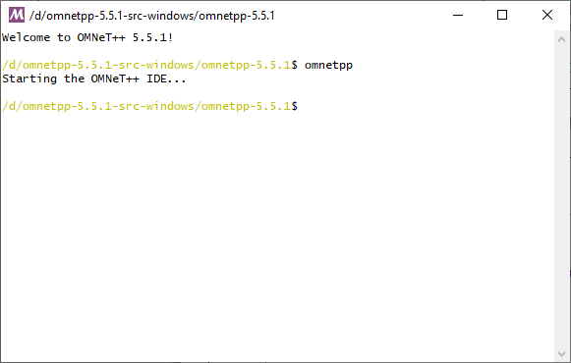**Step 1:** Go to omnetpp-5.5.1 folder in which open “mingwenv.cmd” file, we get following window. Type “omnetpp” command to open omnet++ IDE.

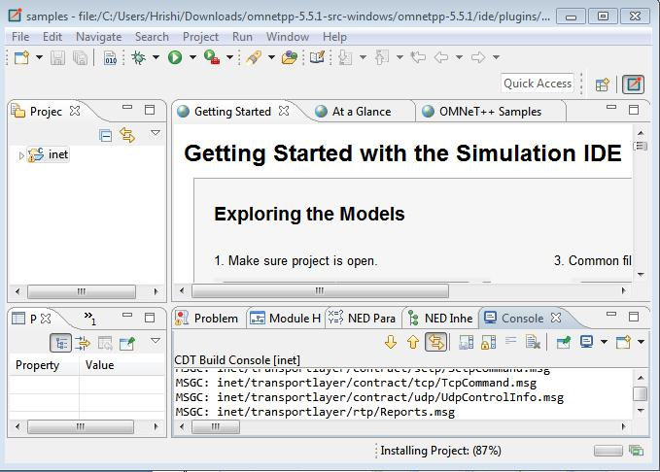**Step 2:** after that command, following window will open.

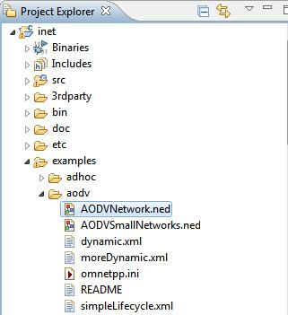**Step 3:** Go to project Explorer > inet > examples > aodv and open AODVNetwork.ned file.

**AODVNetwork.ned:**

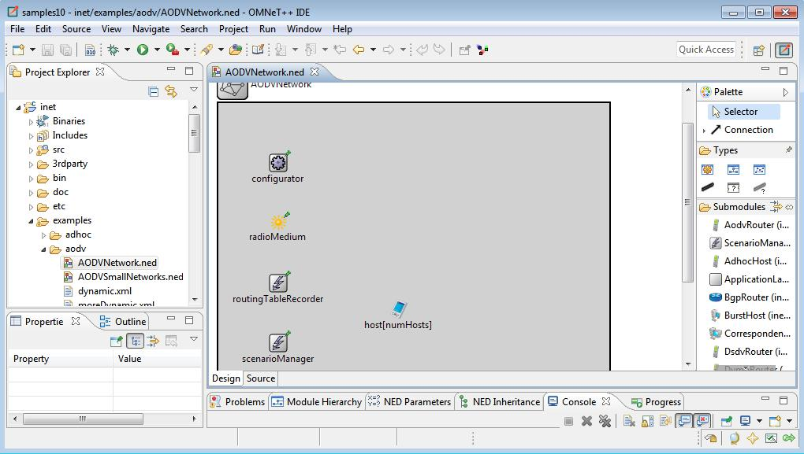

**Coding:**

**AODVNetwork.ned:**

package inet.examples.aodv;

import inet.common.scenario.ScenarioManager;

import inet.networklayer.configurator.ipv4.Ipv4NetworkConfigurator; import inet.networklayer.ipv4.RoutingTableRecorder; import inet.node.aodv.AodvRouter;

import inet.physicallayer.unitdisk.UnitDiskRadioMedium;

network AODVNetwork

{

parameters:

int numHosts;

@display("bgb=650,650");

submodules:

radioMedium: UnitDiskRadioMedium {

parameters:

@display("p=100,200;is=s");

}

configurator: Ipv4NetworkConfigurator {

parameters:

config = xml("<config><interface hosts='*' address='145.236.x.x' netmask='255.255.0.0'/></config>");

@display("p=100,100;is=s");

}

routingTableRecorder: RoutingTableRecorder {

parameters:

@display("p=100,300;is=s");

}

scenarioManager: ScenarioManager {

parameters:

script = default(xml("<scenario/>"));

@display("p=100,400;is=s");

}

host[numHosts]: AodvRouter {

parameters:

@display("i=device/pocketpc_s;r=,,#707070");

}

connections allowunconnected:

}

**Omnetpp.ini:**

[General]

network = AODVNetwork

*#record-eventlog = true*

num-rngs = 3

debug-on-errors = true

**.mobility.rng-0 = 1

**.wlan[*].mac.rng-0 = 2

*# channel physical parameters*

**.wlan[*].typename = "AckingWirelessInterface"

**.wlan[*].bitrate = 2Mbps

**.wlan[*].mac.headerLength = 20B

**.wlan[*].radio.typename = "UnitDiskRadio"

**.wlan[*].radio.transmitter.headerLength = 96b

**.wlan[*].radio.transmitter.communicationRange = 250m

**.wlan[*].radio.transmitter.interferenceRange = 0m

**.wlan[*].radio.transmitter.detectionRange = 0m

**.wlan[*].radio.receiver.ignoreInterference = true

*.numHosts = 20

*# mobility*

**.host[*].mobility.typename = "StationaryMobility"

**.mobility.constraintAreaMinZ = 0m

**.mobility.constraintAreaMaxZ = 0m

**.mobility.constraintAreaMinX = 0m

**.mobility.constraintAreaMinY = 0m

**.mobility.constraintAreaMaxX = 600m

**.mobility.constraintAreaMaxY = 600m

*ping app (host[0] pinged by others)* *.host[0].numApps = 1 *.host[0].app[0].typename = "PingApp" *.host[0].app[0].startTime = uniform(1s,5s) *.host[0].app[0].printPing = true

*nic settings*

**.wlan[*].bitrate = 2Mbps

**.wlan[*].mgmt.frameCapacity = 10

**.wlan[*].mac.retryLimit = 7

*# lifecycle*

**.hasStatus = true

[Config Static]

description = routing without mobility

*.host[*].wlan[*].radio.transmitter.communicationRange = 250m *.host[0].app[0].destAddr = "host[1](ipv4)" [Config IPv4SlowMobility]

description = two fixed communicating nodes with low speed mobile nodes extends = Static

*# mobility*

**.aodv.activeRouteTimeout = 3s

**.host[2..20].mobility.typename = "MassMobility" **.host[0].mobility.typename = "StationaryMobility" **.host[1].mobility.typename = "StationaryMobility" **.host[*].mobility.changeInterval = normal(5s, 0.1s) **.host[*].mobility.angleDelta = normal(0deg, 30deg) **.host[*].mobility.speed = normal(2mps, 0.01mps) **.host[1].mobility.initialX = 600m **.host[1].mobility.initialY = 600m [Config IPv4ModerateFastMobility]

description = two fixed communicating nodes with moderate speed mobile nodes extends = IPv4SlowMobility

*# mobility*

**.aodv.activeRouteTimeout = 2s

**.host[*].mobility.speed = normal(8mps, 0.01mps)

[Config IPv4FastMobility]

description = two fixed communicating nodes with high speed mobile nodes extends = IPv4SlowMobility

*# mobility*

**.aodv.activeRouteTimeout = 1s

**.host[*].mobility.speed = normal(15mps, 0.01mps)

[Config Dynamic]

description = one node is shut down and restarted trigger route changes extends = Static

*.host[*].hasStatus = true

*.scenarioManager.script = xmldoc("dynamic.xml")

[Config MoreDynamic]

description = some nodes are shut down trigger route changes extends = Static

*.host[*].hasStatus = true

*.scenarioManager.script = xmldoc("moreDynamic.xml")

[Config SimpleRREQ]

description = demonstrates a single RREQ-RREP exchange network = SimpleRREQ

*# nic settings*

**.wlan[*].radio.transmitter.communicationRange = 240m

**.sender.numApps = 1

**.sender.app[0].typename = "PingApp"

**.sender.app[0].startTime = uniform(1s,5s)

**.sender.app[0].printPing = true

**.sender.app[0].destAddr = "receiver(ipv4)"

[Config SimpleRREQ2]

description = demonstrates a single RREQ-RREP exchange with two intermediate nodes

extends = SimpleRREQ

network = SimpleRREQ2

[Config SimpleLifecycle]

description = demonstrates AODV's RERR mechanism when a node shuts down extends = SimpleRREQ2

*.scenarioManager.script = xmldoc("simpleLifecycle.xml")

[Config ShortestPath]

description = demonstrates that AODV chooses the shorter path

network = ShortestPath

extends = SimpleRREQ

**Step 4:** Click on Run button.

**Step 5:** After that following window will open.

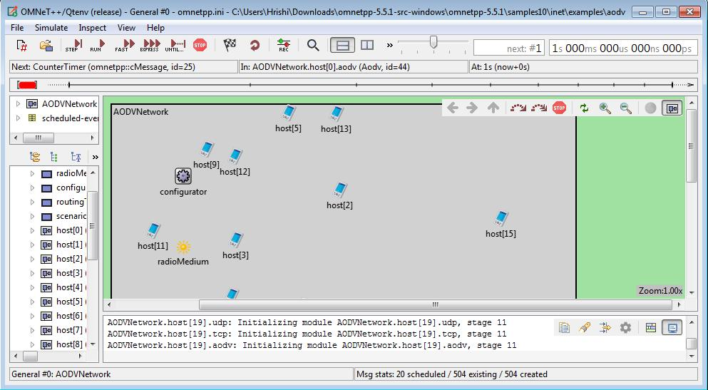

**Step 6:**Click on RUN.

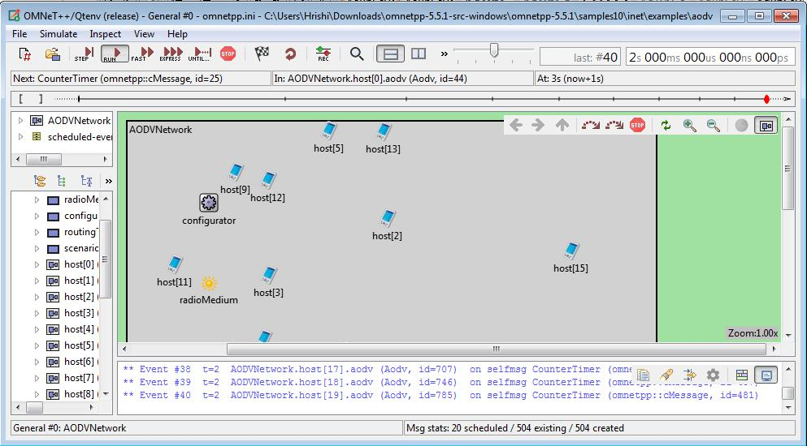

**OUTPUT:**

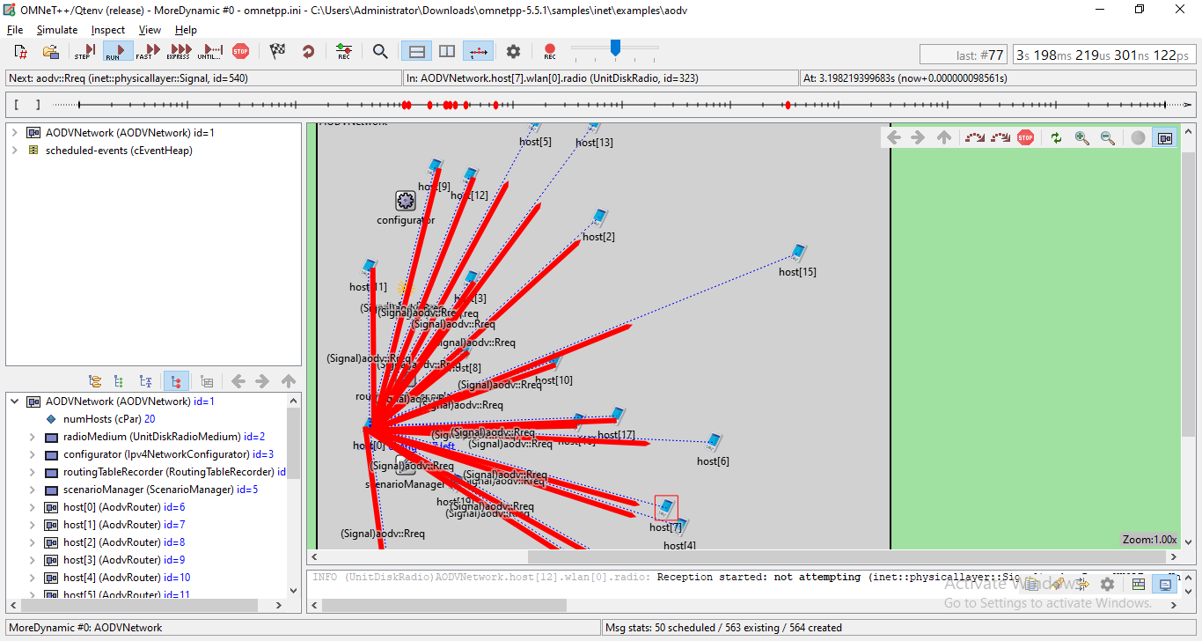

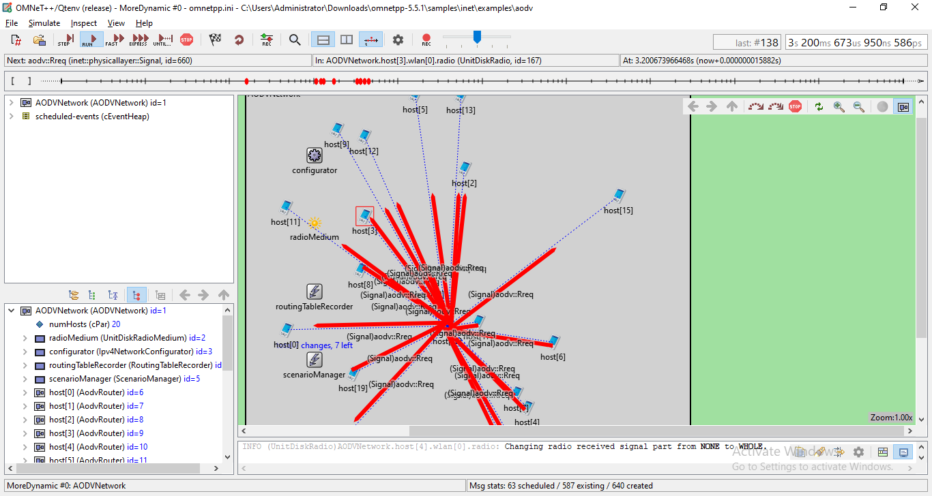

**Conclusion:** We have learnt to MANET simulation for AODVUU Network.